**DEPLOY GUIDE API**



**Mobile Working Report**

**Fujitsu Indonesia**

**API : Applications Protocol Interface**

1. Setup connection to database

File : **FID-WR\api-fid-wr\lib\mysql.php**

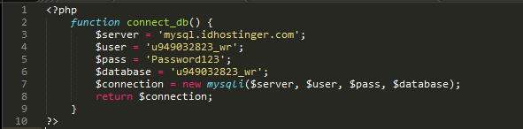

* $server : Host of database
* $user : User of database
* $pass : Password of database
* $database : Database name

1. Function for Auth

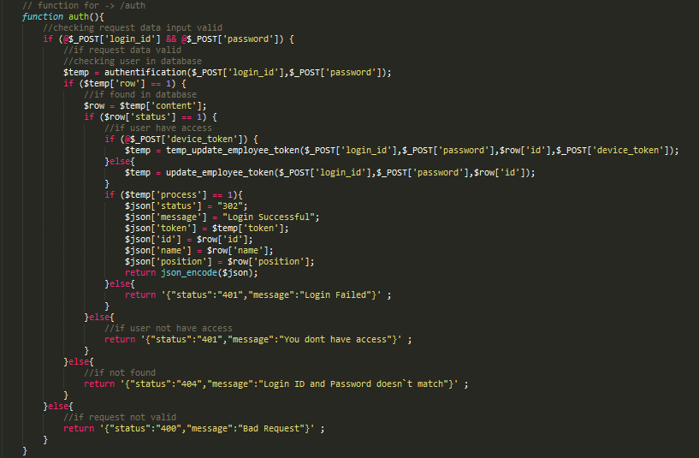

File : **api-fid-wr/mobile-apps.php**

Checking user in database



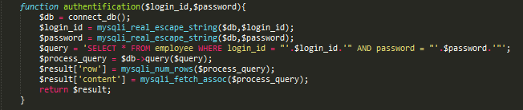

File : **api-fid-wr/lib/extend-function.php**

If user have access



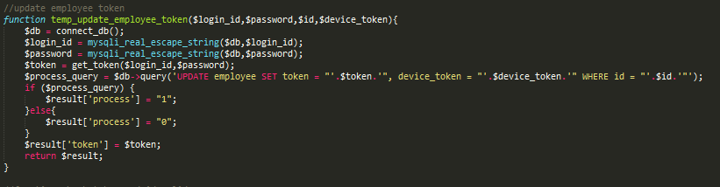

File : **api-fid-wr/lib/extend-function.php**

Else



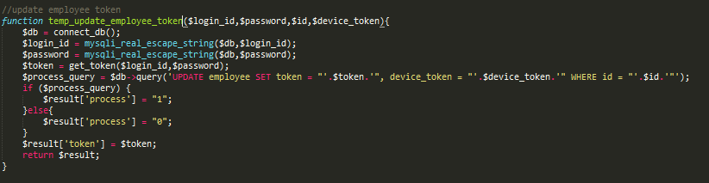

File : **api-fid-wr/lib/extend-function.php**

1. Function for post daily attendance

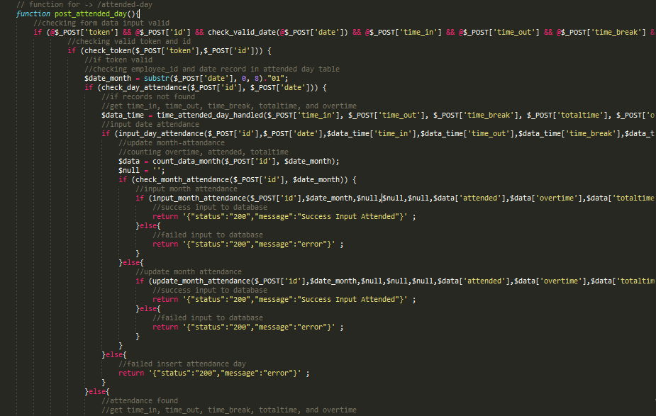

File : **api-fid-wr/mobile-apps.php**

Checking valid token and id



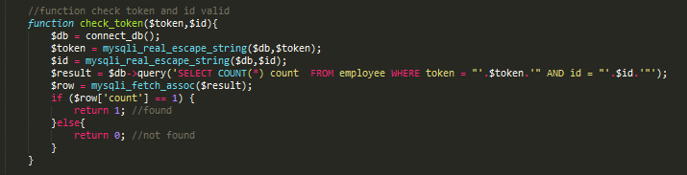

File : **api-fid-wr/lib/extend-function.php**

Checking employee_id and date record in attended day table



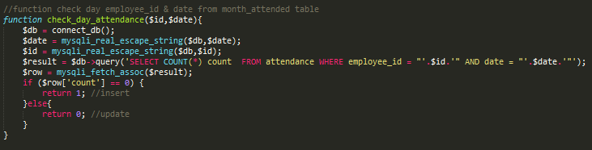

File : **api-fid-wr/lib/extend-function.php**

Get time in, time out, break, totaltime, overtime



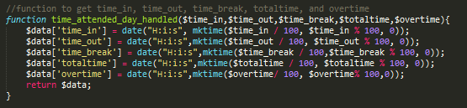

File : **api-fid-wr/lib/extend-function.php**

Input day attended



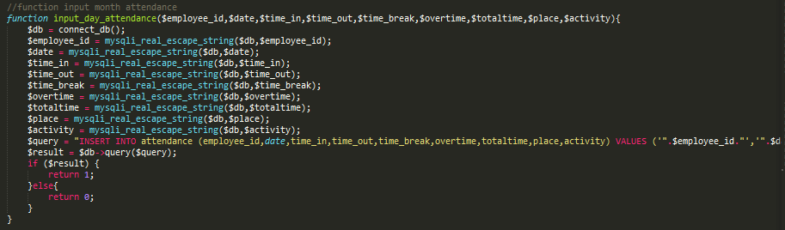

File : **api-fid-wr/lib/extend-function.php**

Counting overtime, attended, totaltime



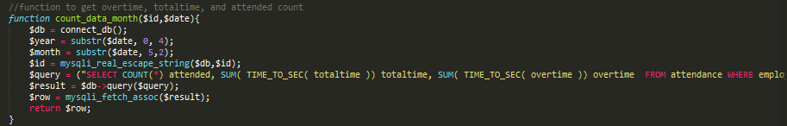

File : **api-fid-wr/lib/extend-function.php**

Input month attendance

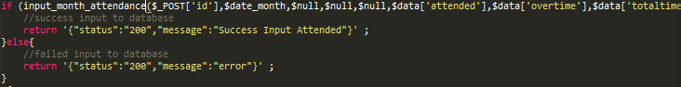

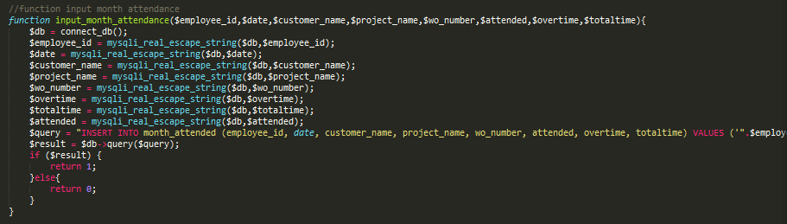

File : **api-fid-wr/lib/extend-function.php**

Else Update month attendance

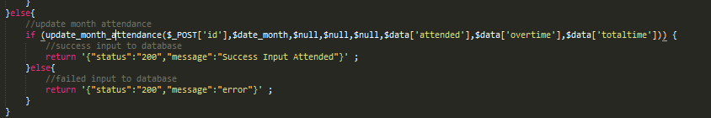

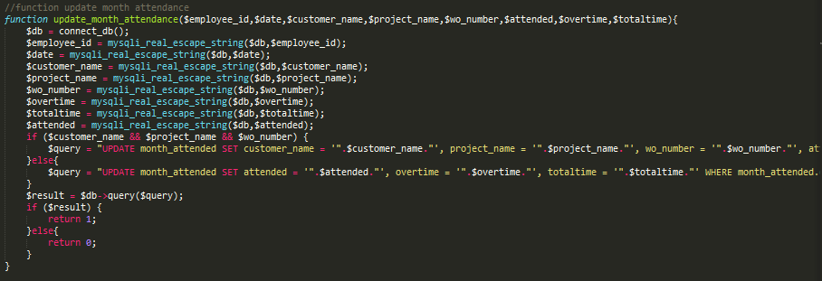

File : **api-fid-wr/lib/extend-function.php**

1. Function for post monthly attendance

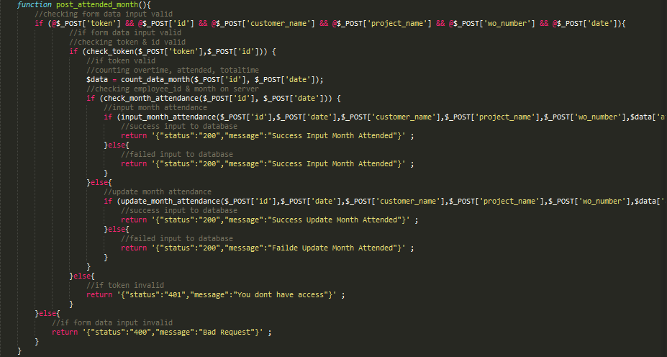

File : **api-fid-wr/mobile-apps.php**

Checking valid token and id





File : **api-fid-wr/lib/extend-function.php**

Checking employee_id & month on server



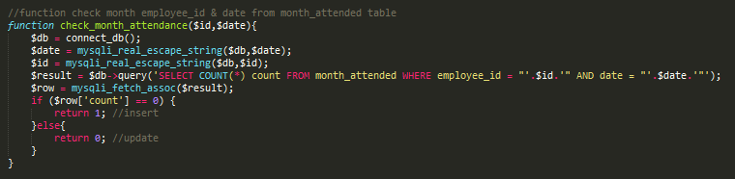

File : **api-fid-wr/lib/extend-function.php**

Input month attendance





File : **api-fid-wr/lib/extend-function.php**

Else update month attendance

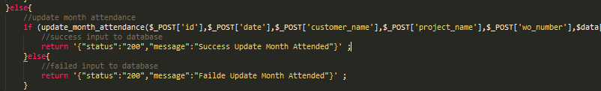



File : **api-fid-wr/lib/extend-function.php**

1. Function for get data month

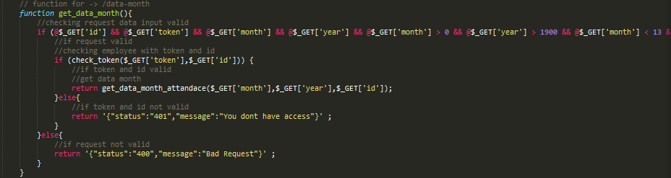

File : **api-fid-wr/mobile-apps.php**

Checking valid token and id





File : **api-fid-wr/lib/extend-function.php**

Get data month attendance



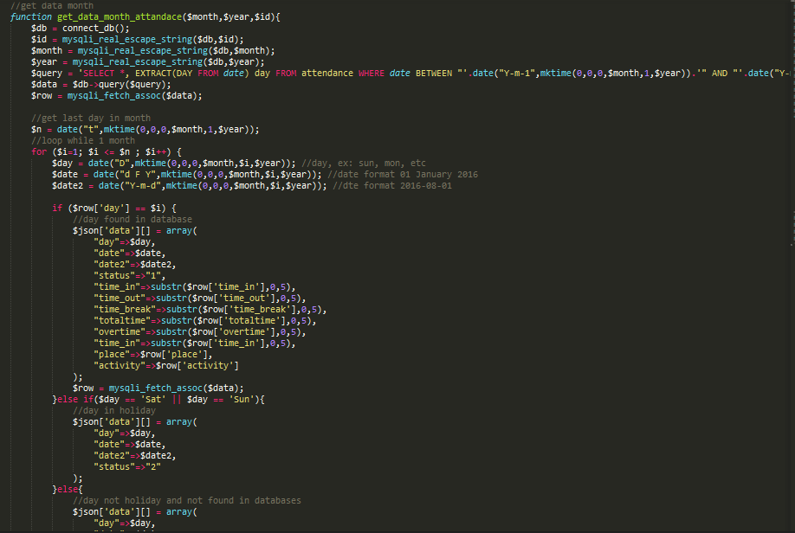

File : **api-fid-wr/lib/extend-function.php**

1. Function for view month attended

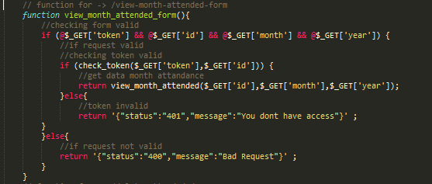

File : **api-fid-wr/mobile-apps.php**

Checking valid token and id





File : **api-fid-wr/lib/extend-function.php**

Get data month attendance



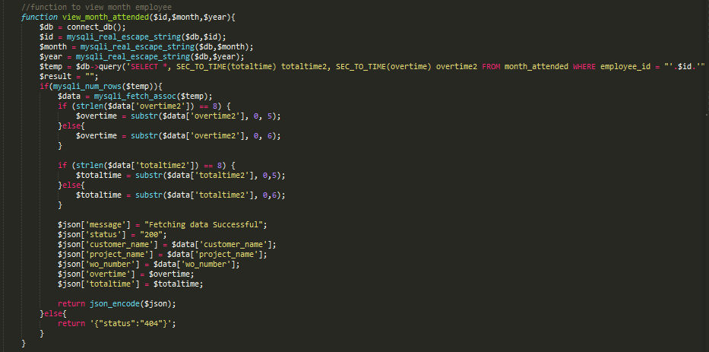

File : **api-fid-wr/lib/extend-function.php**

1. Function for delete attended day

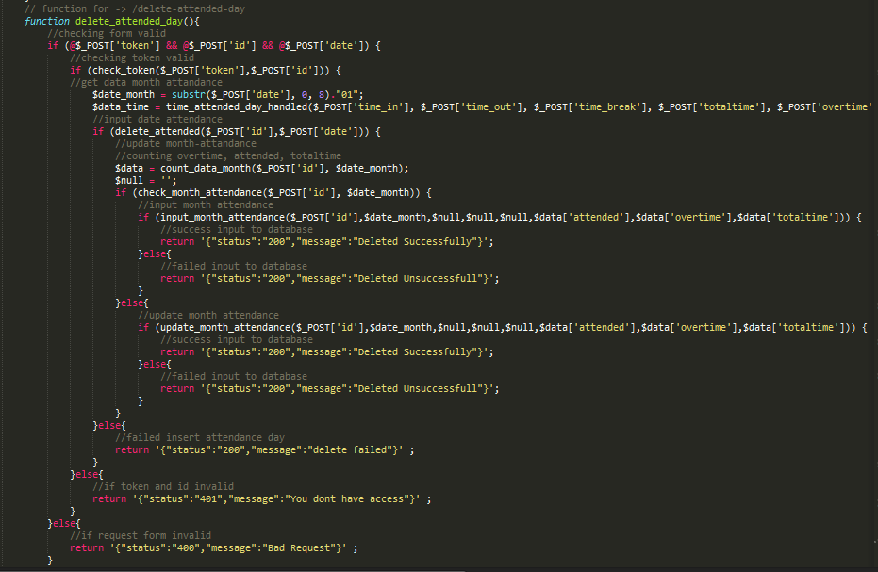

File : **api-fid-wr/mobile-apps.php**

Checking valid token and id





File : **api-fid-wr/lib/extend-function.php**

Get data month attendance



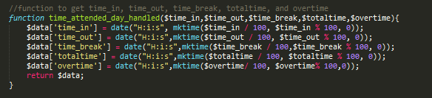

File : **api-fid-wr/lib/extend-function.php**

Input date attendance



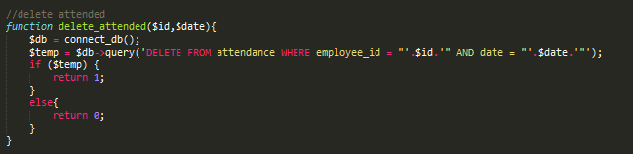

File : **api-fid-wr/lib/extend-function.php**

Counting totaltime, attended, overtime



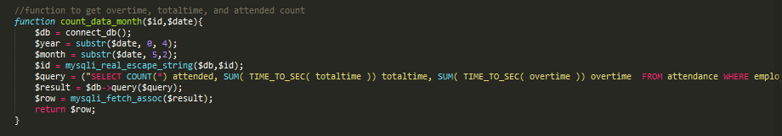

File : **apd-fid-wr/lib/extend-function.php**

Input month attendance

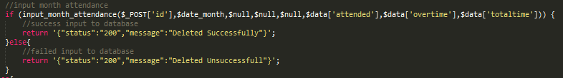

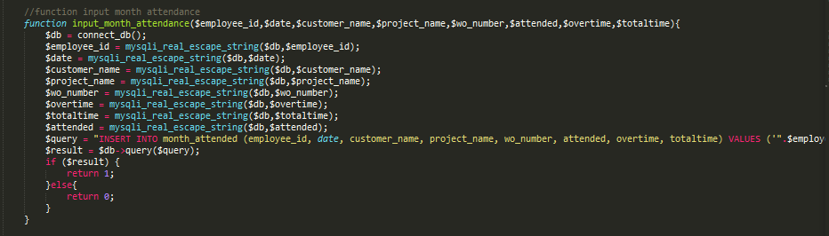

File : **api-fid-wr/lib/extend-function.php**

Else update month attendance

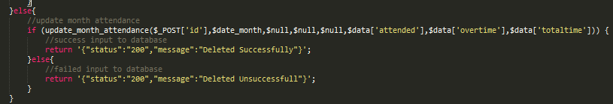

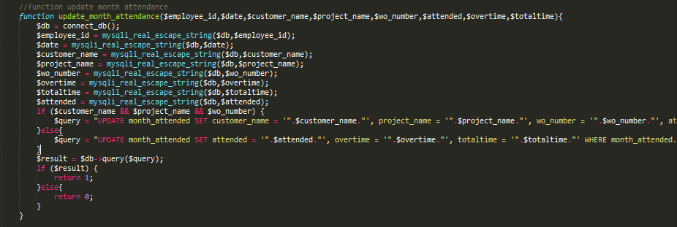

File : **api-fid-wr/lib/extend-function.php**

1. Function for select month

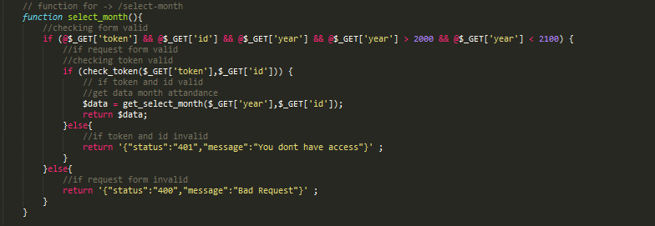

File : **api-fid-wr/mobile-apps.php**

Checking valid token and id





File : **api-fid-wr/lib/extend-function.php**

Get data month attendance

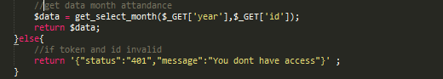

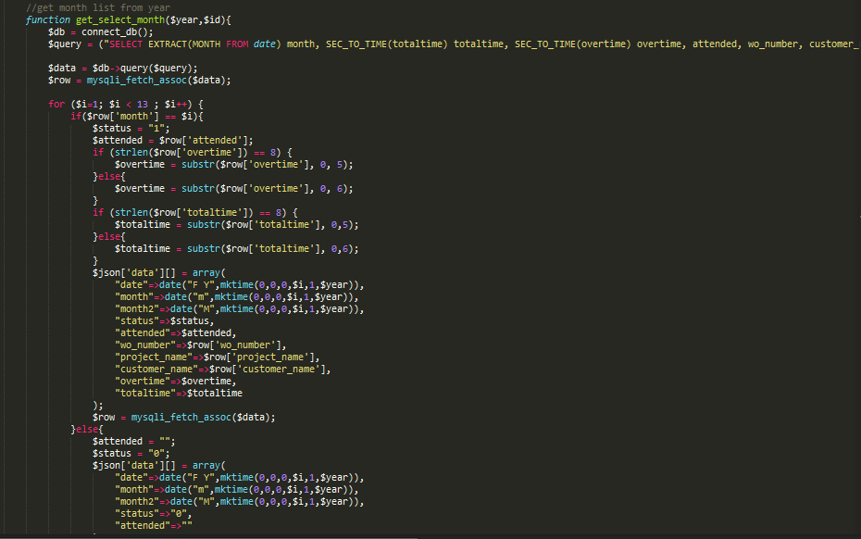

File : **api-fid-wr/lib/extend-function.php**